课程题目
平时练习/作业

班级
姓名
学号
教师
日期

软件与通信学院编制
2023年8月

平时练习1【日期】
题目1 | 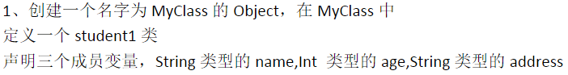
作业级练习题代码原图  及步骤 |  | object MyClass {  class Student1 {  var name: String = _  var age: Int = _  var address: String = _  }  }

题目2 | 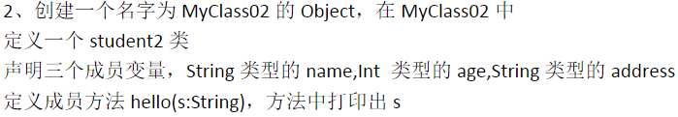
作业级练习题代码原图  及步骤 |  | object MyClass02 {  class Student2 {  var name: String = _  var age: Int = _  var address: String = _  def hello(s: String): Unit = {  println  }  }  }

平时练习2【日期】
题目1 | 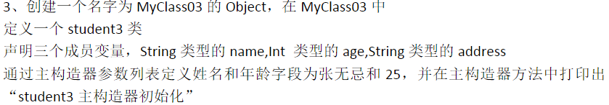
作业级练习题代码原图  及步骤 |  | object MyClass03 {  class Student3(var name: String, var age: Int, var address: String) {  name = "张无忌"  age = 25  println("student3 主构造器初始化")  }  }  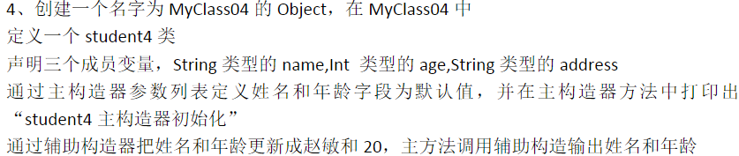  object MyClass04 {  class Student4(var name: String = "张无忌", var age: Int = 25, var address: String) {  println("student4 主构造器初始化")  def this(name: String, age: Int) {  this(name, age, "未知")  this.name = name  this.age = age  println("student4 辅助构造器被调用")  }  }  def main(args: Array[String]): Unit = {  val s4 = new Student4("赵敏", 20)  println(s"姓名：${s4.name}, 年龄：${s4.age}")  }  }  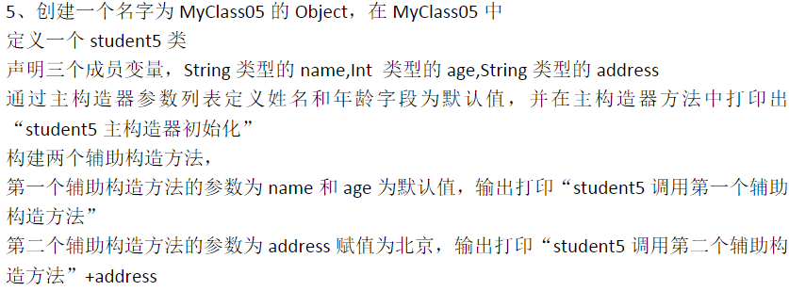  object MyClass05 {  class Student5(var name: String = "张无忌", var age: Int = 25, var address: String = "未知") {  println("student5 主构造器初始化")  def this(name: String) {  this(name, 25, "未知")  println("student5 调用第一个辅助构造方法")  }  def this(address: String) {  this("张无忌", 25, address)  println("student5 调用第二个辅助构造方法" + address)  }  }  }  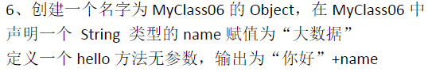  object MyClass06 {  val name: String = "大数据"  def hello(): Unit = {  println("你好" + name)  }  }  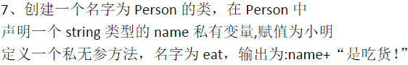  class Person {  private val name: String = "小明"  private def eat(): Unit = {  println(name + "是吃货！")  }  }  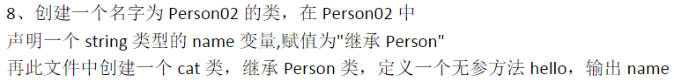  class Person02 {  var name: String = "继承 Person"  }  class Cat extends Person02 {  def hello(): Unit = {  println(name)  }  }  def isEvenOrOdd(num: Int): String = {  if (num % 2 == 0) {  return "偶数"  } else {  return "奇数"  }  }  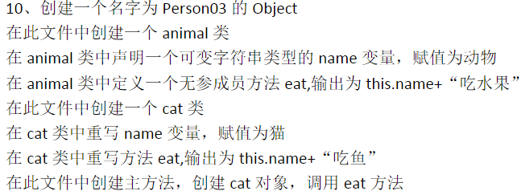  object Person03 {  }  class Animal {  var name: String = "动物"  def eat(): Unit = {  println(this.name + "吃水果")  }  }  class Cat extends Animal {  override var name: String = "猫"  override def eat(): Unit = {  println(this.name + "吃鱼")  }  }  object Main {  def main(args: Array[String]): Unit = {  val cat = new Cat  cat.eat()  }  }  class Calculation {  def add(a: Double, b: Double): Double = {  a + b  }  def subtract(a: Double, b: Double): Double = {  a - b  }  def multiply(a: Double, b: Double): Double = {  a * b  }  def divide(a: Double, b: Double): Double = {  if (b != 0) a / b  else throw new IllegalArgumentException("除数不能为0")  }  }  class Time(val hours: Int, val minutes: Int) {  def before(other: Time): Boolean = {  if (hours < other.hours || (hours == other.hours && minutes < other.minutes)) {  true  } else {  false  }  }  }

